
Symbiosis Institute of Technology, Pune
Department of Computer Science and Engineering
Academic Year 2025-26
Compiler Construction Lab
Batch 2022-26 – Sem VII
Lab Assignment No: - 5
Name of Student | Utsav Sangani
PRN No. | 22070122241
Batch | 2022-26
Class | CSE-C3
Academic Year & Semester | 2025-26
Date of Submission | 14/8/25
Title of Assignment | Conversion of decimal to hexadecimal number in a file.
Practice Questions | - Write a LEX program for conversion of decimal to hexadecimal number in a file.  - Write a LEX program for decimal to binary conversion.
Source Code | Decimal to Hexadecimal  %{  #include <stdio.h>  #include <stdlib.h>  void toHex(int n) {  if (n == 0) { printf("0"); return; }  if (n < 0) { printf("-"); n = -n; }  char hex[32];  int i = 0;  while (n > 0) {  int rem = n % 16;  if (rem < 10) hex[i] = rem + '0';  else hex[i] = rem - 10 + 'A';  i++;  n /= 16;  }  for (int j = i-1; j >= 0; j--) printf("%c", hex[j]);  }  %}  %%  [0-9]+ { printf("%s -> ", yytext); toHex(atoi(yytext)); printf("\n"); }  -[0-9]+ { printf("%s -> ", yytext); toHex(atoi(yytext)); printf("\n"); }  .|\n { /* ignore */ }  %%  int main() {  yyin = fopen("input.txt", "r");  yylex();  fclose(yyin);  return 0;  }  int yywrap() { return 1; }  Decimal to Binary  %{  #include <stdio.h>  #include <stdlib.h>  void toBinary(int n) {  if (n == 0) { printf("0"); return; }  if (n < 0) { printf("-"); n = -n; }  int bin[32], i = 0;  while (n > 0) {  bin[i++] = n % 2;  n /= 2;  }  for (int j = i-1; j >= 0; j--) printf("%d", bin[j]);  }  %}  %%  [0-9]+ { printf("%s -> ", yytext); toBinary(atoi(yytext)); printf("\n"); }  -[0-9]+ { printf("%s -> ", yytext); toBinary(atoi(yytext)); printf("\n"); }  .|\n { /* ignore */ }  %%  int main() {  yyin = fopen("input.txt", "r");  yylex();  fclose(yyin);  return 0;  }  int yywrap() { return 1; }
Output Screenshot | Output File:  Binary to hexadecimal  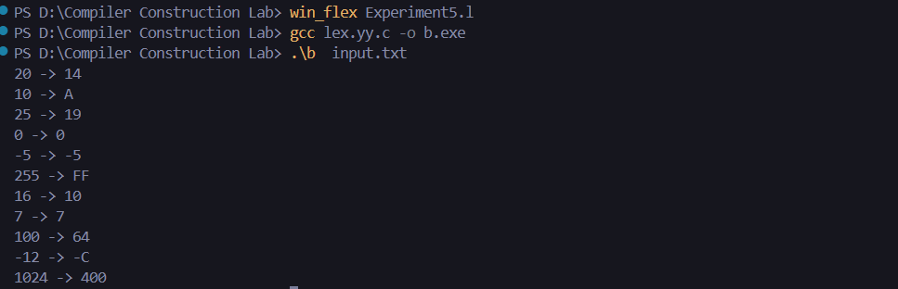  decimal to binary  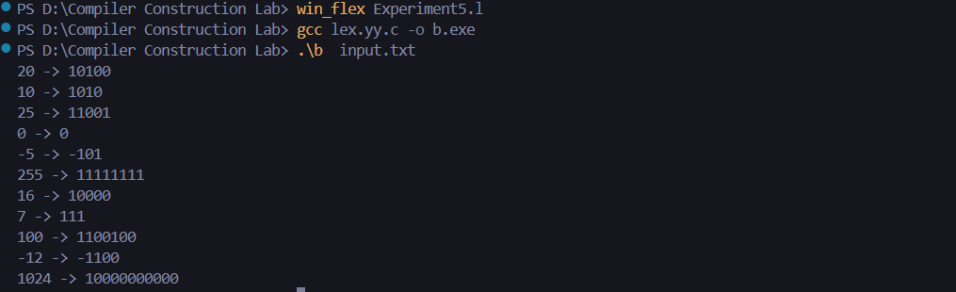
Conclusion | Thus, we have the scanner for a decimal to hexadecimal and decimal to binary conversion.

